|  |
| --- |
| **LAPORAN PRAKTIKUM JARINGAN KOMPUTER**  **3.4.5**  **PACKET TRACER – CONFIGURE TRUNKS** |
|  |
| **Agus Pranata Marpaung**  **13323033**  **DIII TEKNOLOGI KOMPUTER** |
| **INSTITUT TEKNOLOGI DEL**  **FAKULTAS VOKASI** |

**Judul Praktikum**

|  |  |  |
| --- | --- | --- |
| **Minggu/Sesi** | : | XI/2 |
| **Kode Mata Kuliah** | : | 4332101 |
| **Nama Mata Kuliah** | : | JARINGAN KOMPUTER |
| **Setoran** | : | Jawaban dalam bentuk *softcopy* |
| **Batas Waktu Setoran** | : | *?* |
| **Tujuan** | : | 1. Mahasiswa mampu mengamankan perangkat jaringan dan memecahkan masalah pada konektivitas setiap perangkat. |

**Petunjuk**



**Packet Tracer - Configure Trunks**

# Addressing Table

|  |  |  |  |  |  |
| --- | --- | --- | --- | --- | --- |
| **Device** | **Interface** | **IP Address** | **Subnet Mask** | **Switch Port** | **VLAN** |
| PC1 | NIC | 172.17.10.21 | 255.255.255.0 | S2 F0/11 | 10 |
| PC2 | NIC | 172.17.20.22 | 255.255.255.0 | S2 F0/18 | 20 |
| PC3 | NIC | 172.17.30.23 | 255.255.255.0 | S2 F0/6 | 30 |
| PC4 | NIC | 172.17.10.24 | 255.255.255.0 | S3 F0/11 | 10 |
| PC5 | NIC | 172.17.20.25 | 255.255.255.0 | S3 F0/18 | 20 |
| PC6 | NIC | 172.17.30.26 | 255.255.255.0 | S3 F0/6 | 30 |

# Objectives

**Part 1: Verify VLANs**

**Part 2: Configure Trunks**

# Background

Trunks are required to pass VLAN information between switches. A port on a switch is either an access port or a trunk port. Access ports carry traffic from a specific VLAN assigned to the port. A trunk port by default is a member of all VLANs. Therefore, it carries traffic for all VLANs. This activity focuses on creating trunk ports and assigning them to a native VLAN other than the default.

# Instructions

# Part 1: Verify VLANs

**Step 1: Display the current VLANs.**n configuration window

1. On **S1**, issue the command that will display all VLANs configured. There should be ten VLANs in total. Notice that all 26 access ports on the switch are assigned to VLAN 1.

**Answer:**

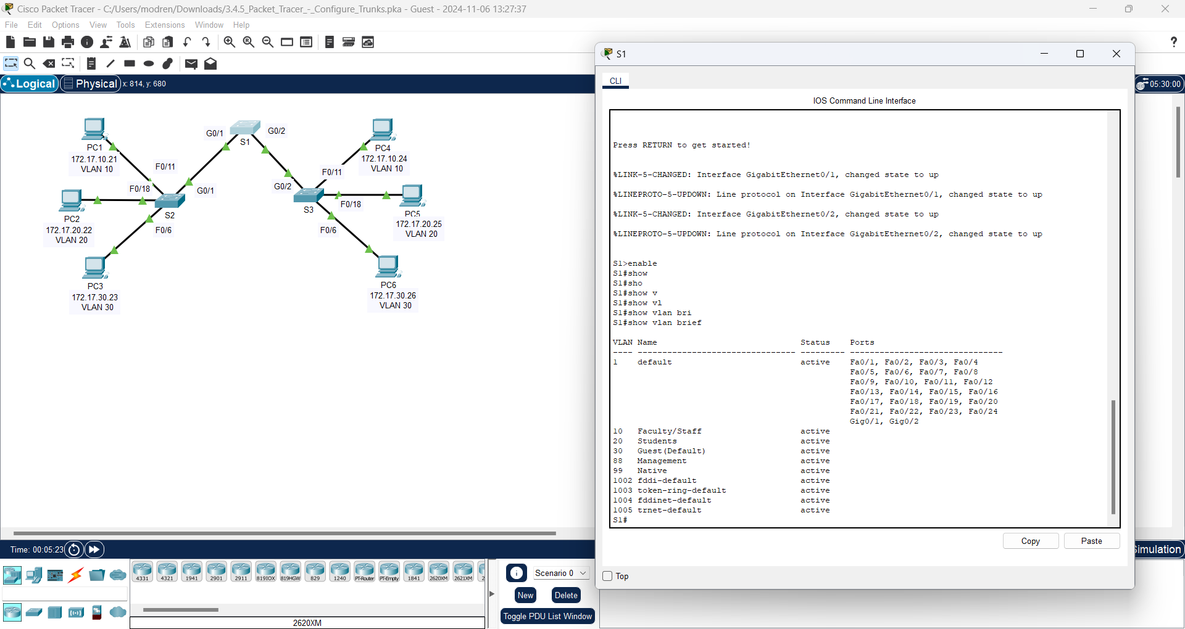

1. On **S2** and **S3**, display and verify that all the VLANs are configured and assigned to the correct switch ports according to the **Addressing Table**.

**Answer:**

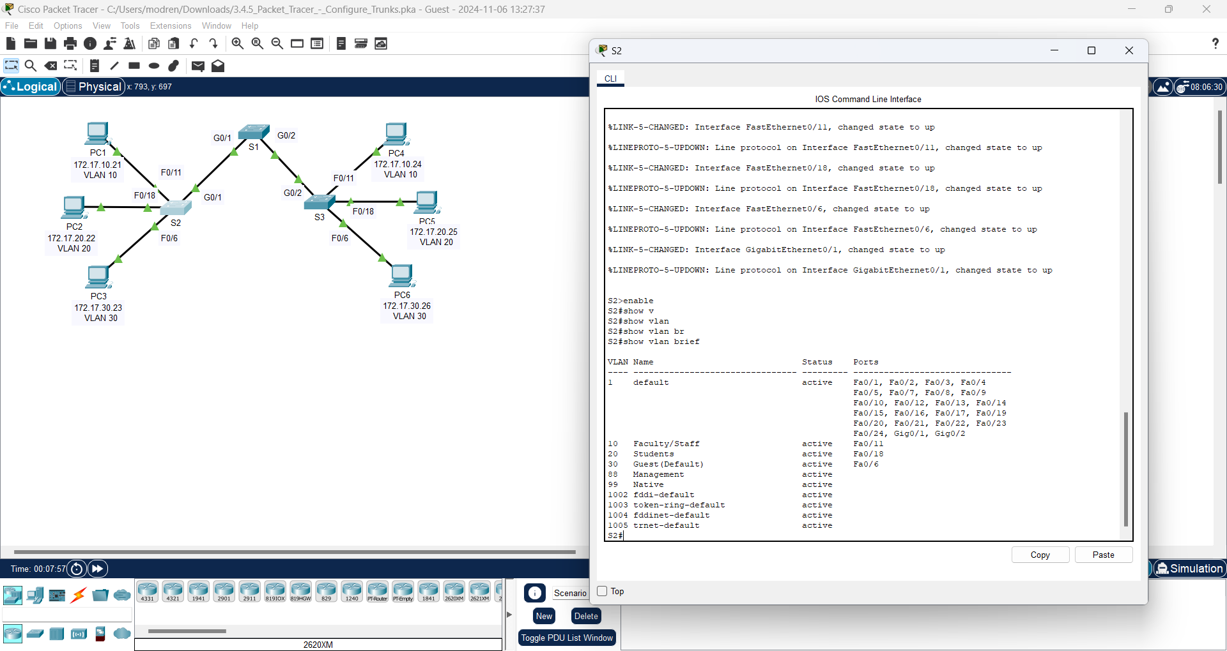

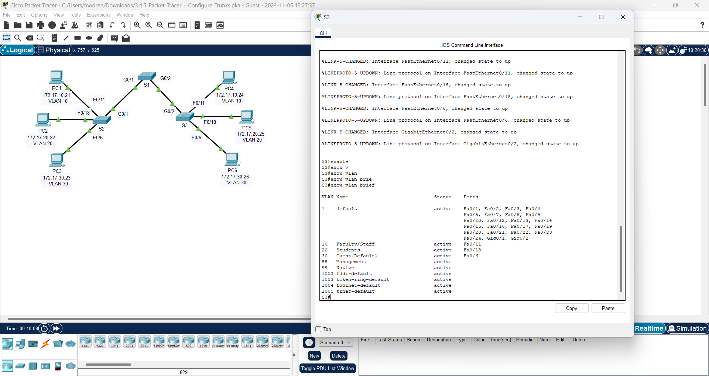

**Step 2: Verify loss of connectivity between PCs on the same network.**

Ping between hosts on the same the VLAN on the different switches. Although **PC1** and **PC4** are on the same network, they cannot ping one another. This is because the ports connecting the switches are assigned to VLAN 1 by default. In order to provide connectivity between the PCs on the same network and VLAN, trunks must be configured.

# Part 2: Configure Trunks

**Step 1: Configure trunking on S1 and use VLAN 99 as the native VLAN.**

ndow

1. Configure G0/1 and G0/2 interfaces on S1 for trunking.

S1(config)# **interface range g0/1 - 2**

S1(config-if)# **switchport mode trunk**

**Answer:**

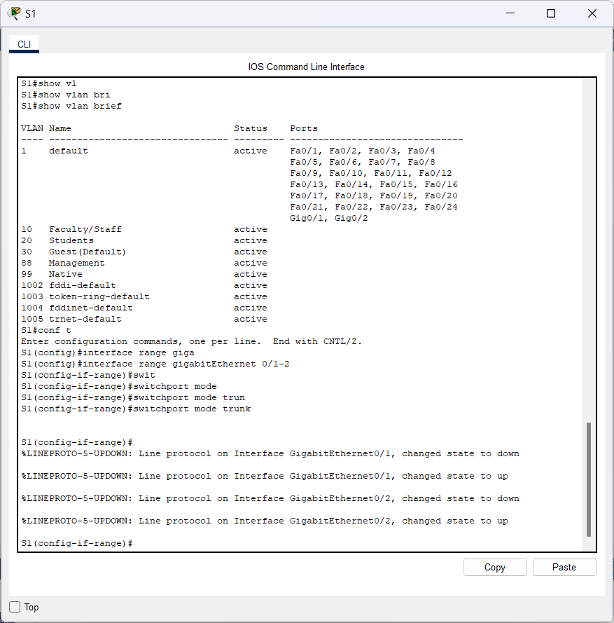

1. Configure VLAN 99 as the native VLAN for G0/1 and G0/2 interfaces on **S1**.

S1(config-if)# **switchport trunk native vlan 99**

**Answer:**

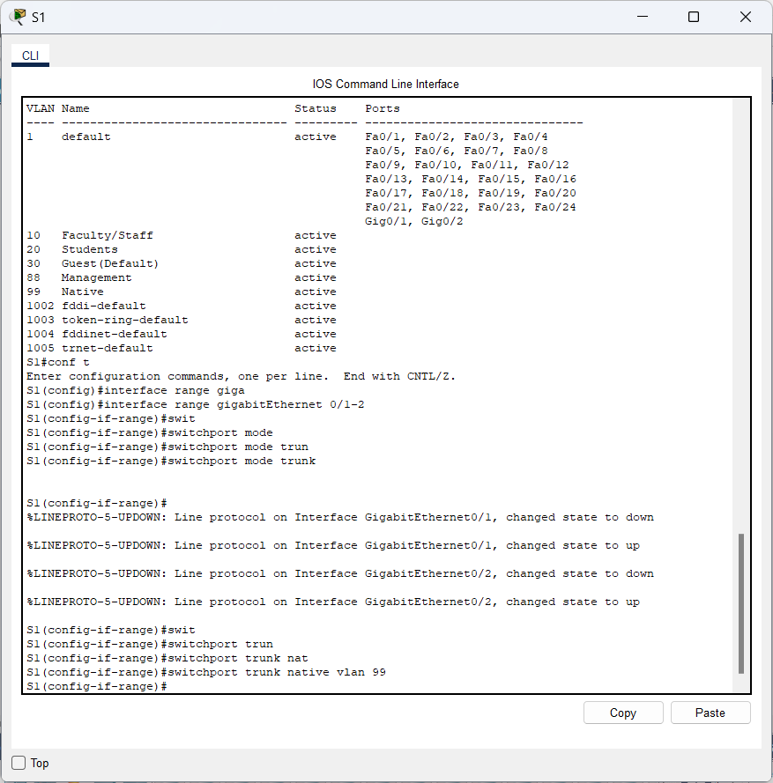

The trunk port takes about a short time to become active due to Spanning Tree Protocol. Click **Fast Forward Time** to speed the process. After the ports become active, you will periodically receive the following syslog messages:

%CDP-4-NATIVE_VLAN_MISMATCH: Native VLAN mismatch discovered on GigabitEthernet0/2 (99), with S3 GigabitEthernet0/2 (1).

%CDP-4-NATIVE_VLAN_MISMATCH: Native VLAN mismatch discovered on GigabitEthernet0/1 (99), with S2 GigabitEthernet0/1 (1).

**Answer:**

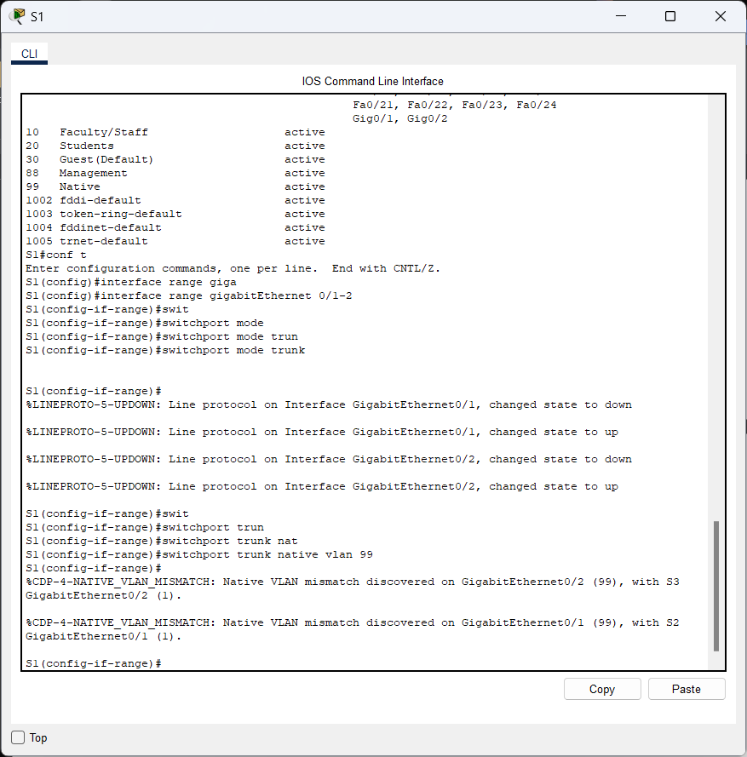

You configured VLAN 99 as the native VLAN on S1. However, S2 and S3 are using VLAN 1 as the default native VLAN as indicated by the syslog message.

Although you have a native VLAN mismatch, pings between PCs on the same VLAN are now successful. Explain.

**Answer:**

IP Address pada PC4

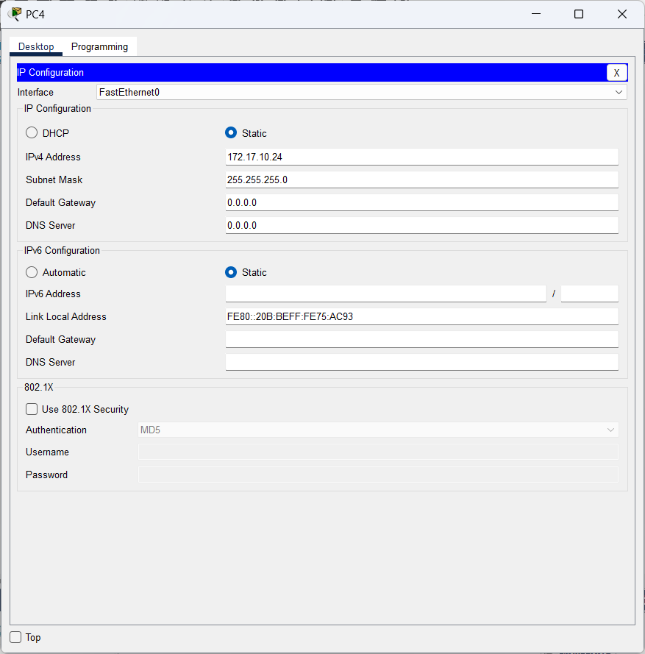

Kemudian, kita lakukan ping dari PC1 ke PC4

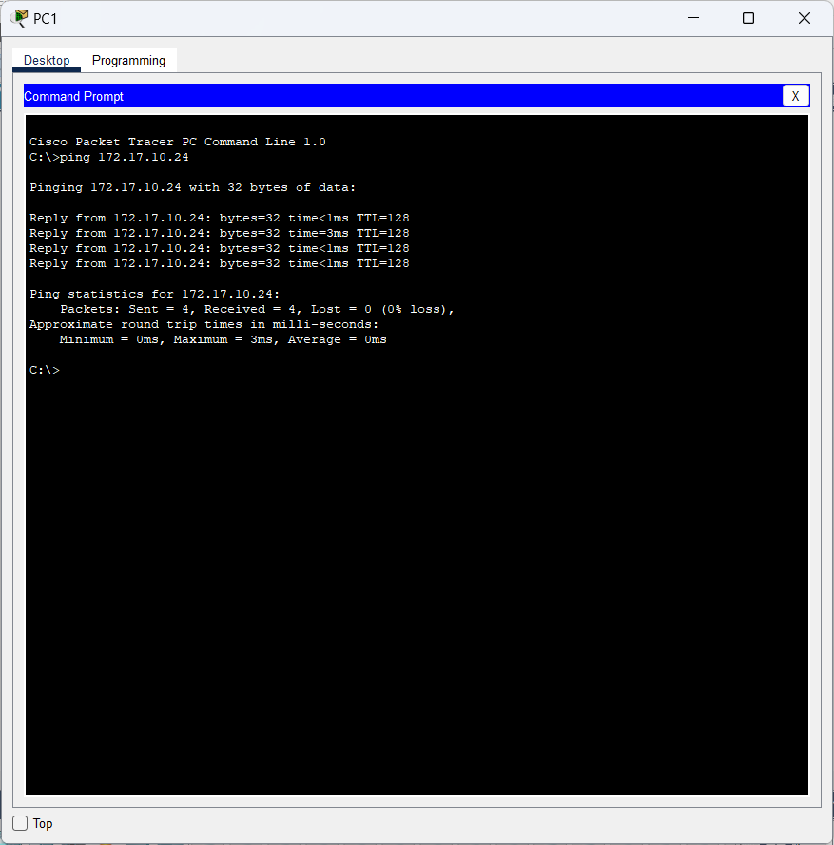

**Penjelasannya:**

Ini disebut Dynamic Trunking Protocol (DTP) yang sudah didefault oleh Cisco Switches protokol DTP ini sudah dinyalakan. Ini berarti bahwa kita sudah mengkonfigurasi trunk pada satu sisi yang dikaitkan dan di sisi lainnya juga akan di trunk secara otomatis.**r answers here.**

**Step 2: Verify trunking is enabled on S2 and S3.**

On **S2** and **S3**, issue the **show interface trunk** command to confirm that DTP has successfully negotiated trunking with S1 on S2 and S3. The output also displays information about the trunk interfaces on S2 and S3.

You will learn more about DTP later in the course.

Which active VLANs are allowed to cross the trunk?

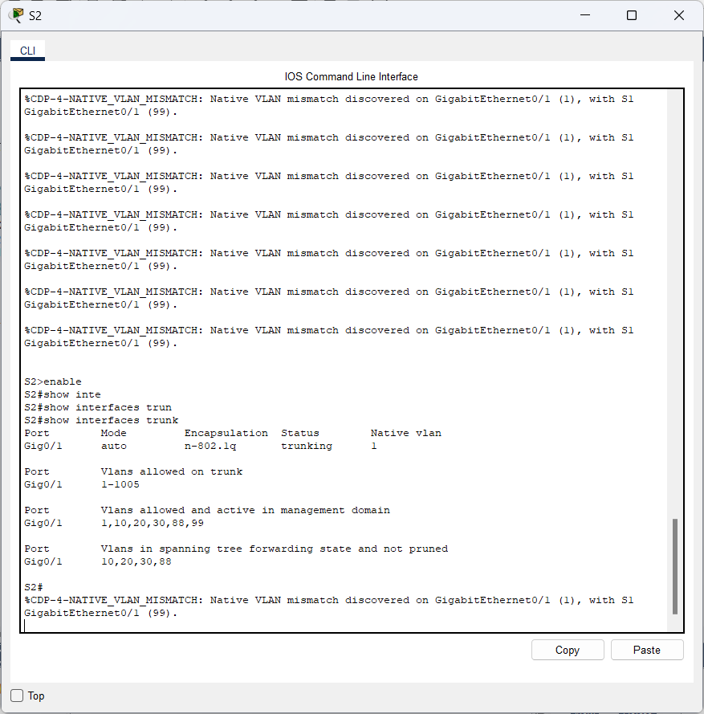

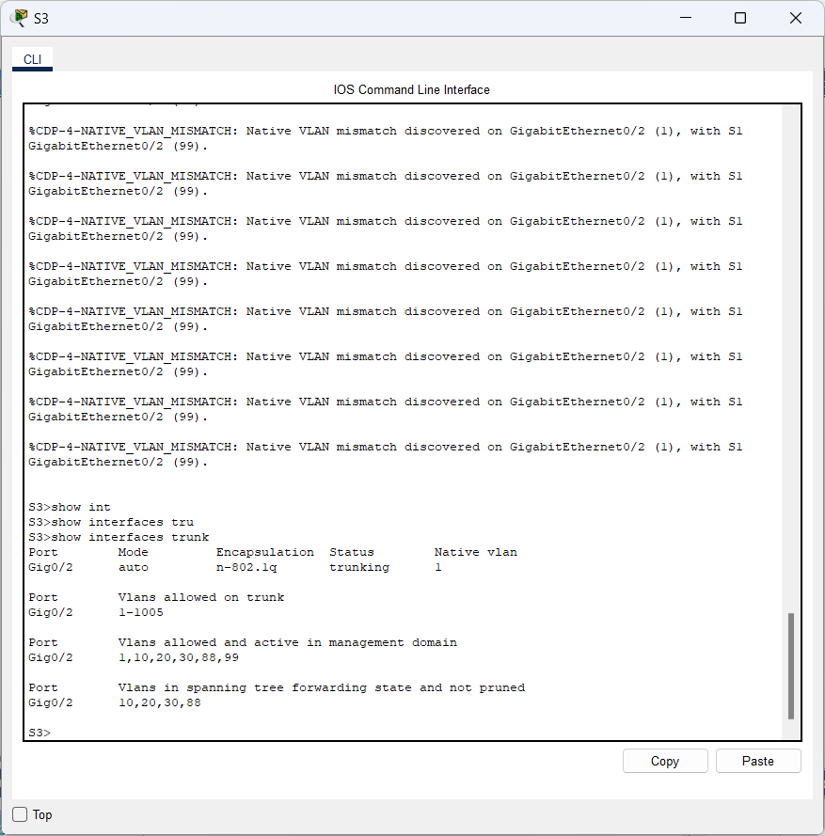

**Step 3: Correct the native VLAN mismatch on S2 and S3.**

1. Configure VLAN 99 as the native VLAN for the appropriate interfaces on S2 and S3.

**Answer:**

* **S2**

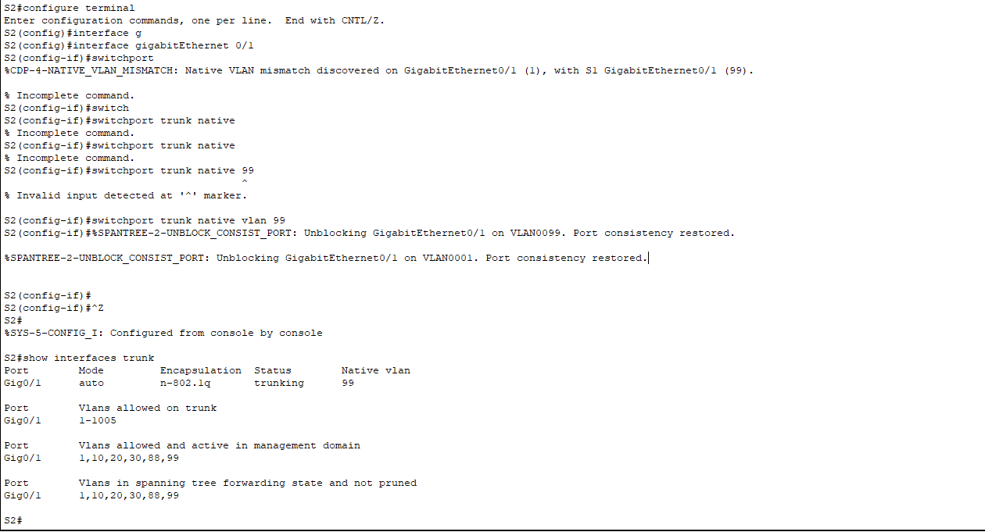

* **S3**

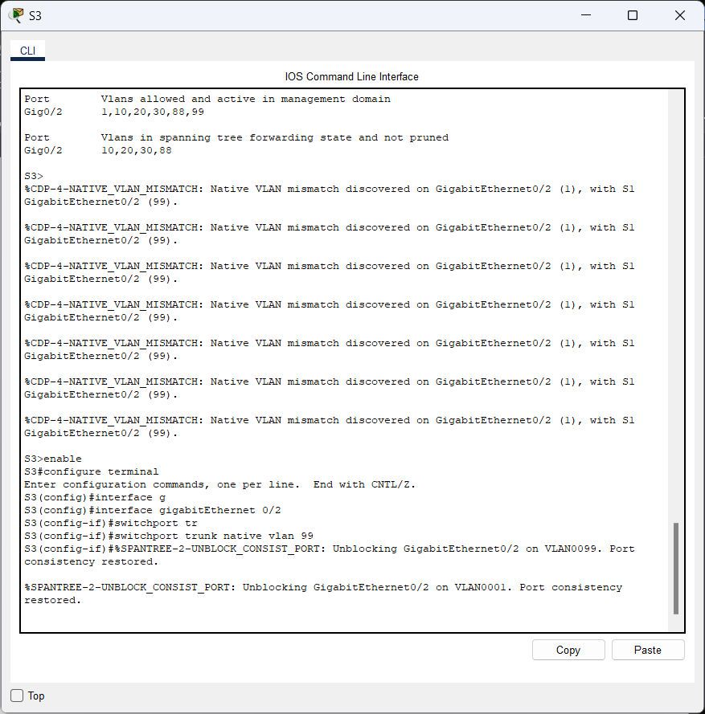

1. Issue **show interface trunk** command to verify the correct native VLAN configuration.

**Answer:**

* **S2**



* **S3**

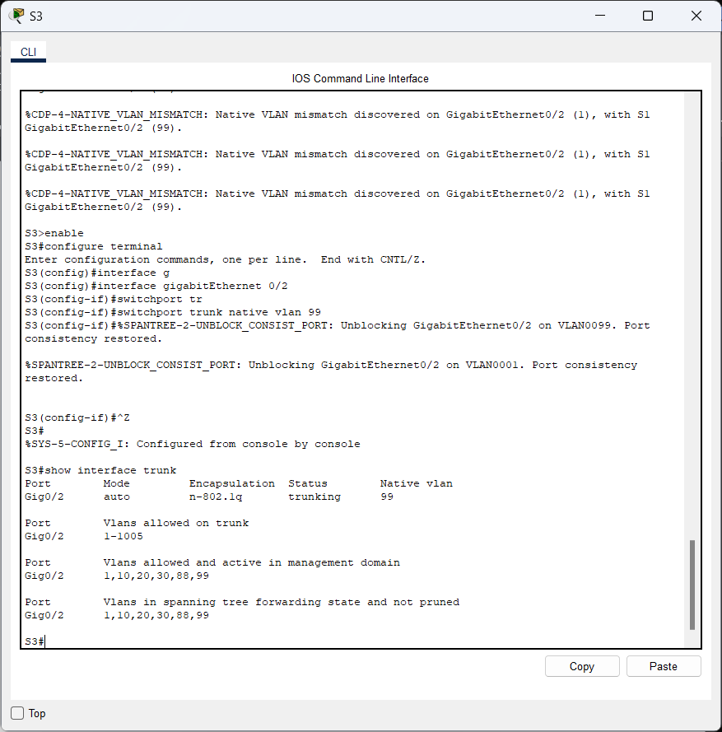

**Step 4: Verify configurations on S2 and S3.**

1. Issue the **show interface** interface **switchport** command to verify that the native VLAN is now 99.

**Answer:**

* **S2**

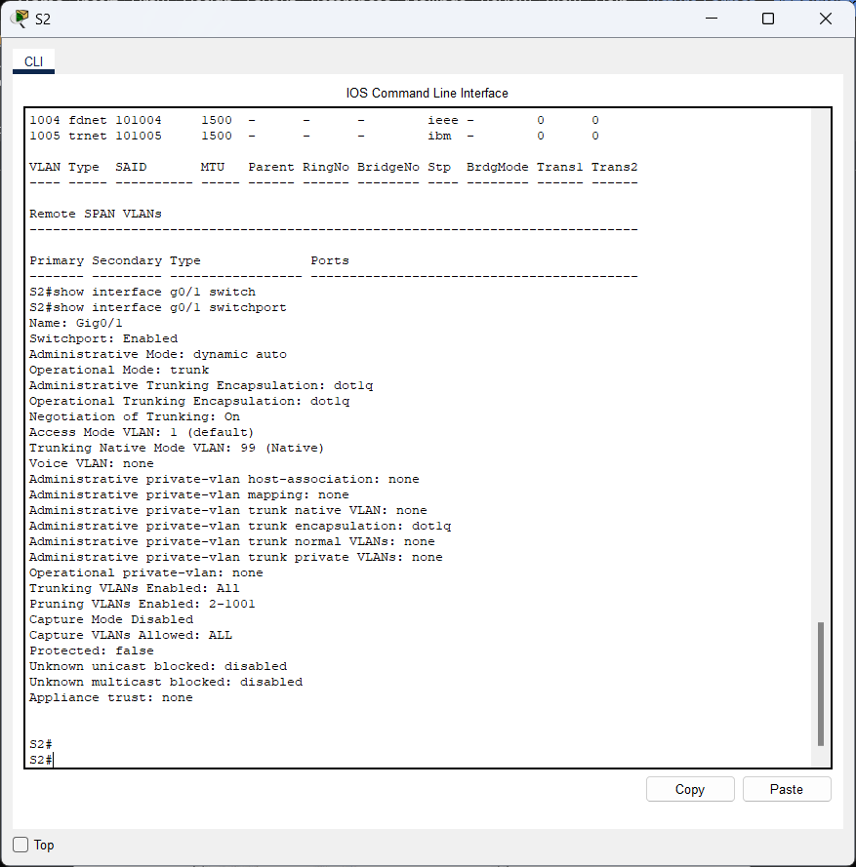

* **S3**

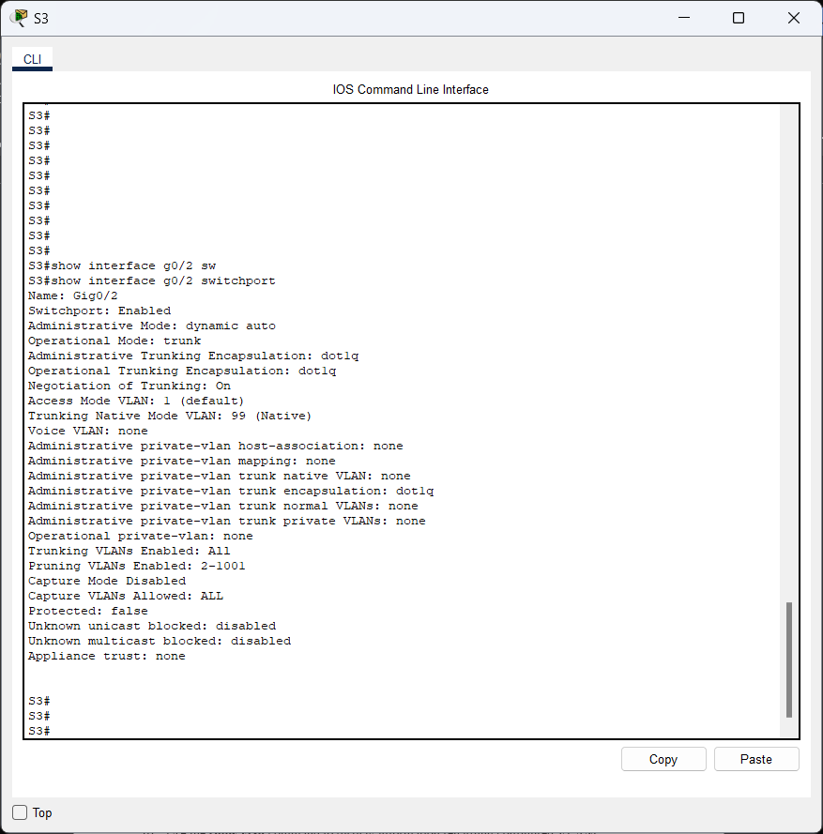

1. Use the **show vlan** command to display information regarding configured VLANs.

**Answer:**

* **S2**

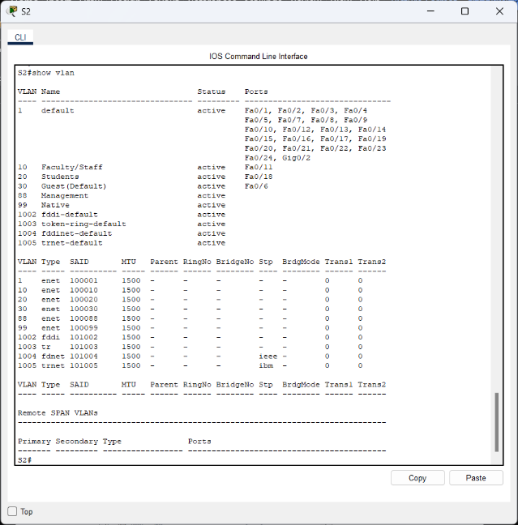

* **S3**

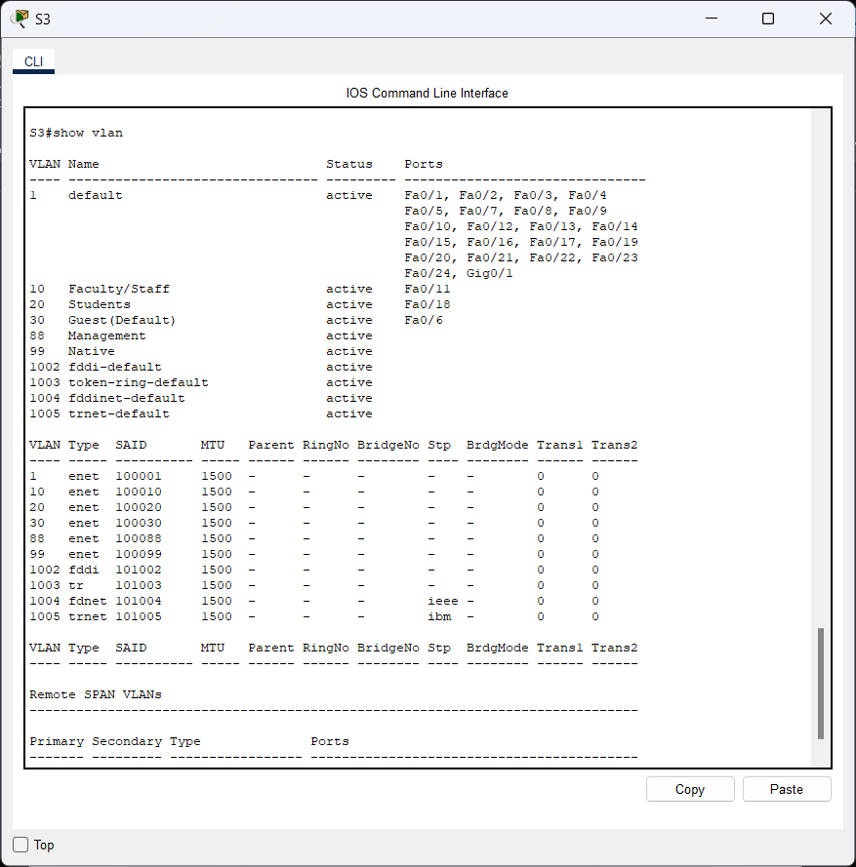

Why is port G0/1 on S2 no longer assigned to VLAN 1?

**Answer:**

Port G0/ adalah port trunk dan port trunk lainnya tidak ditampilkan.